Life in Christ: Session Four
Sin and Temptation

OVERVIEW: Throughout the creation account God has communicated His motivation, design and purpose for creation, especially the creation of humankind and His desire to live in relationship with people. He is not interested in religious rituals, works done by people to appease God or earn something from Him.
It is also clear that God reveals Himself to us according to how He wants us to engage in relationship with Him. It is impossible for us to know Him by our own reason or intellect, rather we know Him through His Words: creation, the Bible, and Jesus Christ. God has chosen to reveal Himself and express His desire for relationship in understandable terms; as the creator and sustainer of all things, He wants us to see Him as our loving and gracious Father.
God was pleased with His creation and very pleased with humans which He made in His own image because of the type of relationship He longs to have with us. We are the focus of His love and His expectation is that we will respond to Him by loving and trusting Him.
Everything God made during creation was exactly as He designed and intended. But it did not remain that way. That which was created complete had been broken. That which was healthy became terminally ill. That which was free became enslaved and cursed.

A Good World in Perfect Harmony
The Trinity:

This term, The Trinity, is not found anywhere in Scripture, and yet it is a fundamental belief and teaching of Christian doctrine. In fact, it is seen as a “litmus test” for whether a church or denomination is considered to be a truly orthodox Christian group.

BUT, if it’s not in the Bible, how did we get it? Can we defend it? Why is it important?

- There is only one God, not three different gods.
  - Polytheism is the term for a religion that worships many gods.
  - Deuteronomy 6:4 = monotheism
- One God: Three Persons
  - Modalism
  - Partialism
  - Arianism
  - Trinitarian
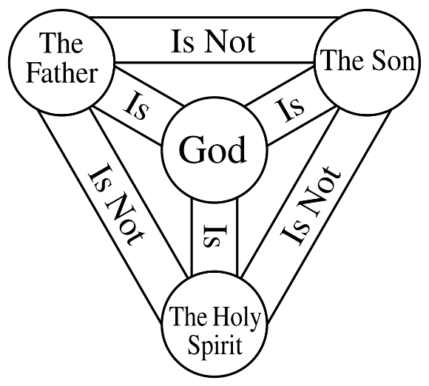
- Scriptures that reveal the Trinity
  - Genesis 1:1-3
  - Matthew 3:13-17
- The doctrine of the Trinity is vital to Salvation
  - Jesus Christ is Divine

The Original Design:

How good was the world that God had made?
- The Hebrew word is “tov”, which means “exceedingly good” and “beautiful”.
- God thought of everything:
  - Food and shelter (eat and enjoy)
  - Significant purpose and task (stewardship of creation)
  - Belonging and companionship (with Him and one another)
  - Value and identity (made in His image)
  - Expectations and Trust
- Law and Grace as foundations for life

The Fall: The Destruction of Good
Genesis 3:1 and following verses:

- The Serpent:
- God’s Command:
- The Temptation:
- The Actual Lie:
- Their Sin:
- A Guilty Verdict:
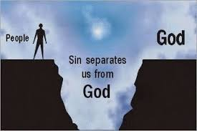
- The Excuses:
- The Consequences:
- The Promise:

Sin and Sins: An Important Distinction

Sin | Sins

Consider a common prayer of confession:
Most merciful God, we confess that [Sin] we are by nature sinful and unclean. [Sins]We have sinned against You in thought, word, and deed, by what we have done and by what we have left undone. We have not loved You with our whole heart; we have not loved our neighbors as ourselves. We justly deserve Your present and eternal punishment.

Why confess both?

Why confess at all?

1st John 2:2

1st John 4:10

Romans 5

1st John 1

The Devil (Serpent): He Made Me Do It

The Trifecta:
- Responsibility
- Trust
- Accountability

The Devil – what do we know about him?

“There are two equal and opposite errors into which our race can fall about the devils. One is to disbelieve in their existence. The other is to believe, and to feel an excessive and unhealthy interest in them. They themselves are equally pleased by both errors. And hail a materialist or a magician with the same delight.” Preface to The Screwtape Letters, by C.S. Lewis

Isaiah 14:12-17 = What do we learn about “the morning star” (AKA: Lucifer)?

Beware of dualism!
This is a heresy that elevates evil and specifically Satan to be the opposite and equal of God and all that is good. This heresy is symbolized by the yin and yang symbol, it is also very common in: culture, literature, and movies (light and dark sides of the force in Star Wars).
“The commonest question is whether I really ‘believe in the Devil’. Now, if by ‘the Devil’ you mean a power opposite to God and, like God, self-existent from all eternity, the answer is certainly NO. There is no uncreated being except God. God has no opposite. No being could attain a 'perfect badness’ opposite to the perfect goodness of God; for when you have taken away every kind of good thing (intelligence, will, memory, energy, and existence itself) there would be none of him left.
The proper question is whether I believe in devils. I do. That is to say, I believe in angels, and I believe that some of these, by the abuse of their free will, have become enemies to God and, as a corollary, to us. These we may call devils. They do not differ in nature from good angels, but their nature is depraved. Devil is the opposite of angel only as Bad Man is the opposite of Good Man. Satan, the leader or dictator of devils, is the opposite of, NOT God, but of Michael.”

Free Will: The Great Risk
God created us (remember, He said it was good; exactly as He planned) with the ability to say “No”. As part of His design, humans could choose to disobey Him; could choose to reject Him and His love.
Why is this important?

What does it reveal about God?

What does it tell us about ourselves?

Original Sin
An important teaching of Scripture is that we inherited a sin nature from Adam and Eve. Every person ever conceived has a sin nature, systemically broken. Nobody starts out whole or innocent. Simply stated, we are all broken and live in a broken world.
Psalm 51 =

Romans 3:10-12 =

Romans 5:15-17 =

The Need for a Savior
If it is not abundantly clear that we are in desperate need of a savior, it is pointless to go on. If we are not broken or if we can fix ourselves, then Christ did not need to come – live – die – and rise again; His death and sacrifice was in vain.
John 3:3 =

Ephesians 2:1 =

Romans 7:7

Our brokenness goes way beyond a Band-Aid or even stitches. A prescription, treatment or surgery will not solve this problem. There are several common ways that people try to deal with this dilemma:
We Can: (Judas Iscariot)
We Can: (I’m Ok, you’re OK)
We Can: (Egocentricity)
OR
We Can: (I cannot – I need)

