Life in Christ: Session Six
Jesus Christ – Savior of the World

OVERVIEW: What exactly happened to Jesus on the cross? We often refer to the gospel and in so doing mean Christ’s death on a cross and His resurrection from the grave. But wait, there is more:
- The full impact of the Crucifixion, both physically and spiritually.
- The Descent into Hell, what is the significance of this obscure doctrine?
- The Resurrection, the ultimate victory!
- God’s overwhelming act of love on our behalf.

The Full, Literal Gospel:
What happened to Christ on the Cross?

The following passages reveal some very startling realities surrounding the passion of Christ.

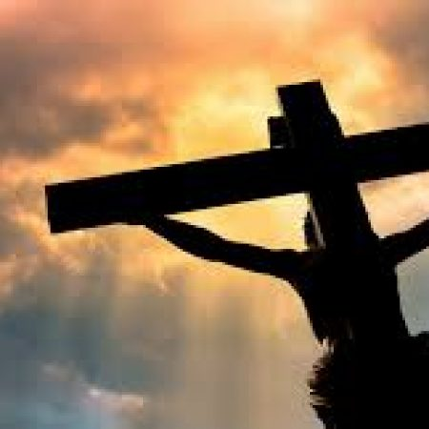
- Psalm 22
- Matthew 27:45-46
- Galatians 3:13
- 2nd Corinthians 5:21
- Isaiah 53

The use of familiar and sanitized terms for the death of Jesus Christ:
Sacrifice, death, suffering, atonement, substitution, and others……
Unfortunately, these terms do not adequately express what really happened to Christ on the cross. There is a danger in familiarity. We have heard the story of Christ’s death and resurrection numerous times; enough exposure to result in a spiritual inoculation. We experience just enough Jesus and His Gospel to prevent us from getting the real thing and keep us from a full experience of the Gospel.

It is almost as if knowing the end of the story diminishes the full impact of the story. Since we know the “rest of the story”; Jesus rises from the dead so His death gets glossed over and treated as though it wasn’t that big of a deal. It is a big deal. Without Good Friday, there is no Easter. In many ways, Christ’s death on the cross has become sterile, clinical, and even civilized. There was nothing civilized about Christ’s death on the cross!

Therefore, we must, for Christ’s honor and our faith, explore the realities of His death and in so doing explore the love that was expressed on that lonely hill outside of Jerusalem.

An excerpt from No Wonder They Call Him the Savior, by Max Lucado.

The despair is darker than the sky. The two who have been one are now two. Jesus, who had been with God for eternity, is now alone. The Christ, who was an expression of God, is abandoned. The Trinity is dismantled. The Godhead is disjointed. The unity is dissolved.
It is more than Jesus can take. He withstood the beatings and remained strong at the mock trials. He watched in silence as those He loved ran away. He did not retalitiate when the insults were hurled nor did He scream when the nails pierced His wrists.
But when God [The Father] turned His head, that was more than He could handle.
“My God!” The wail rises from parched lips. The holy heart is broken. The sinbearer screams as He wanders in the eternal wasteland. Out of the silent sky come the words screamed by all who walk in the desert of loneliness. “Why? Why did you abandon me?”

The just penalty for disobedience = death (Romans 6:23). We are sinners and we sin. The wage for rebelling against God, rejecting His love and grace, disobeying His will is eternal condemnation – eternal separation from the Lord.

Jesus took our place! Jesus was damned! He endured the very pains of hell which were our fate. God the Father turns away, turns His back on Jesus. He must, for in that moment, the Father sees only the sin of all mankind upon His Son. Jesus became sin (2nd Corinthians 5:21). Therefore, He must be punished – and He is.

This truth bears repeating: The Full, Literal Gospel is that Jesus Christ was damned in your place.

The Cross of Christ is the climactic point of human history. All that happened before it points to it. All that happened after it references back to it. The empty tomb is the validation of His sacrifice.

The Descent into Hell

Second Article of The Apostles’ Creed
And in Jesus Christ, His only Son, our Lord, who was conceived by the Holy Spirit, born of the
Virgin Mary, suffered under Pontius Pilate, was crucified, died and was buried. He
descended into hell.

¹⁸ For Christ also suffered^{[b]} once for sins, the righteous for the unrighteous, that he might bring us to God, being put to death in the flesh but made alive in the spirit, ¹⁹ in which^{[c]} he went and proclaimed^{[d]} to the spirits in prison, ²⁰ because^{[e]} they formerly did not obey, when God's patience waited in the days of Noah, while the ark was being prepared, in which a few, that is, eight persons, were brought safely through water. 1st Peter 3:18-20

The innocent Jesus Christ was damned. He paid the FULL penalty for our sin.
Therefore, Jesus suffered the very pangs and pains of hell. He did not approach hell on a white stead with fire in His eyes and a sword in His hand. He did not ride into Hell with trumpets sounding and hoof beats hammering, cutting great swaths of demons along the way. He did not lead an offensive on the gates of Hell – He went bound in chains, the chains of our sin. It was a full payment for our disobedience. He was consigned to Hell itself, and we ought to shudder as we hear the huge gates slam behind Him. It seems as though all hope is gone. It looks like Satan has won. Life is lost. The demons laugh. The Lifegiver has been overwhelmed by sin and death. Satan gloats.
But not for long! The requirements of the Law are clear – disobedience earns the death penalty; the consequences of sin is death, no if’s, and’s or but’s. The condemned can only be redeemed by the blood of a sinless sacrifice. But death gives way to life because this sacrifice is: human, holy, and God Himself. The creator redeems His creatures. The Lord God Almighty is the only one with the means to purchase that which is His own – and He did! The payment has been made. God’s grace is free to you but very costly for Him.

The Ultimate Victory: Jesus is raised from the dead
Second Article of The Apostles’ Creed (continued)
The third day He rose again from the dead. He ascended into heaven and sits at the right hand of God the Father Almighty. From thence He will come to judge the living and the dead.

The Four Gospel Accounts of the Resurrection:
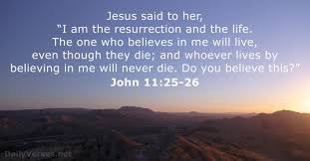
- Matthew 28:1-10
- Mark 16:1-8
- Luke 24:1-10
- John 20

An affirmation by the Apostle Paul:

- 1st Corinthians 15
Worship is Easter

Why do we gather to worship God on Sunday, the 1st day of the week? Every Sunday is a celebration of the Resurrection of Jesus Christ on that 1st Easter Sunday. We don’t celebrate the Lord’s resurrection just once a year – we celebrate it 52 times a year! Every Sunday we gather together as the Body of Christ to celebrate Jesus’ victory over sin, death and the Devil. Every Sunday we worship Him, praise Him and give thanks to Him for taking the death penalty that we deserve. We gather together in His presence and receive His gifts of grace so that we might live a new life – He lives and we too shall live.

On each Lord’s Day, God graciously operates on us first and our actions are a grateful response to His activity. Indeed, our words and actions are energized by the Holy Spirit’s ongoing operations throughout the Divine Service. Therefore, the primary purpose of the corporate Sunday service is to receive by faith God’s gracious service in Christ and then to respond with corporate and individual thanksgiving in union with Christ and the praising of the One True God. Gottesdienst; God’s service to us and our service to God.

Conclusion
The following Scriptures address: God’s desire for people, Christ’s death, and Christ’s resurrection.

- Ezekiel 18:23 & 32
- Luke 15:11-32
- 1st Timothy 2:4
- 1st Timothy 4:10
- 2nd Peter 3:9

