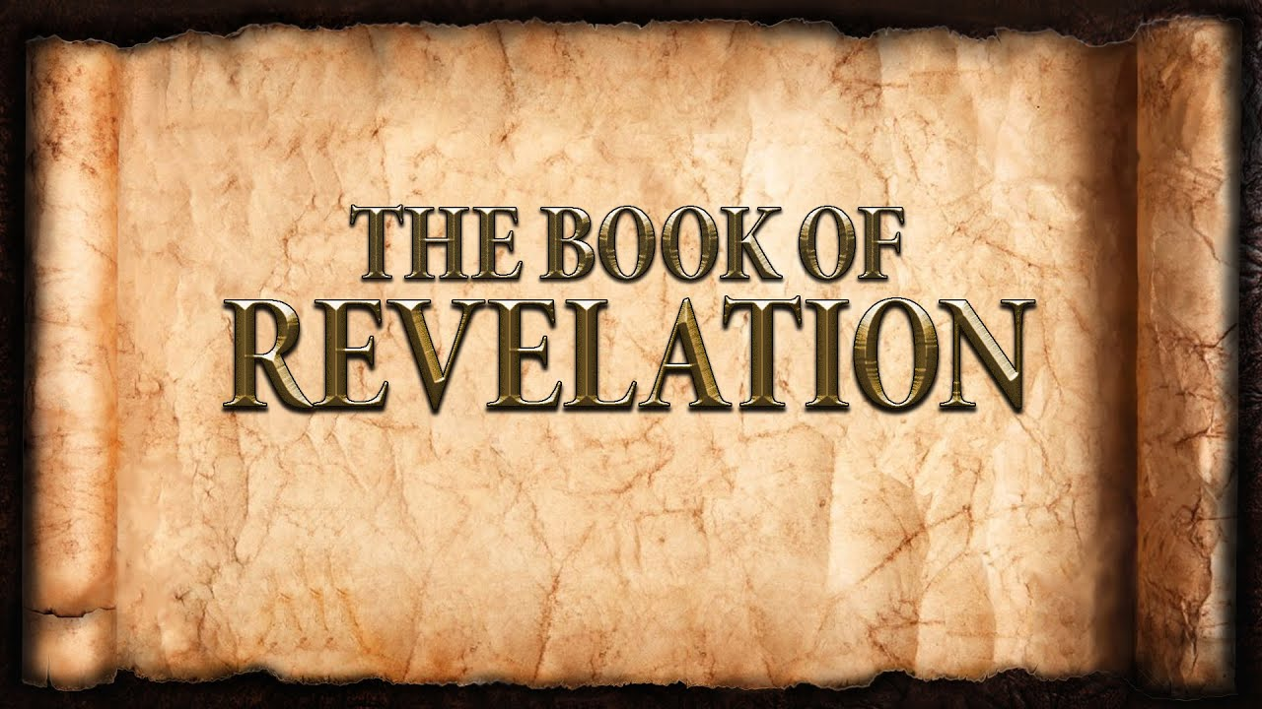
The revelation of Jesus Christ, which God gave him to show to his servants^{[a]} the things that must soon take place. [Revelation 1:1]

There was a man sent from God, whose name was John. ⁷ He came as a witness, to bear witness about the light, that all might believe through him. [John 1:6]

- It is a revelation with a single purpose = believe.
- It is a revelation of the Almighty God.
- It is a revelation of Lord Jesus Christ.
- It is a revelation of the Holy Spirit.

Grace to you and peace from Him who is and who was and who is to come, and from the Seven Spirits who are before his throne, ⁵ and from Jesus Christ the faithful witness, the firstborn of the dead, and the ruler of kings on earth.

To him who loves us and has freed us from our sins by his blood ⁶ and made us a kingdom, priests to his God and Father, to him be glory and dominion forever and ever. Amen. [Revelation 1:4-6]

- Acts 20:28-29
- 1st Peter 1:18-19
- Galatians 5:1
- 1st Peter 2:9
- Romans 8:29
- 1st Corinthians 15:20
- Galatians 2:20

Jesus Christ is:
- ___The Faithful Witness___________________________
- ___The Firstborn of the dead_______________________
- ___The Ruler of Kings____________________________
- ___The One who loves us__________________________
- ___The One who freed us__________________________
- ___The One who made us a Kingdom of Priests_________
- ___The One who deserves all glory____________________

Exodus 3:14 “I AM” = Yahweh
Gospel of John |  | Apocalypse of John
“I Am” Statements | Sign Miracles | “I Am” Statements
6:35, 41, 48-51  Bread of Life | 6:1-15  Feeding the Multitude | 1:8  Alpha & Omega
8:12 - 9:5  Light of the World | 9:1-41  Sight for the blind man | 1:17  The First & The Last
10:7-9  The Door | 5:1-15  The Healing of the invalid | 1:18  He that lives
10:11-14  The Good Shepherd | 6:16-21  Walks on Water | 21:6  Alpha & Omega
11:25  The Resurrection | 11:1-44  Raises Lazarus from the dead | 22:13  Alpha & Omega
14:6  The Way, Truth & Life | 4:46-54  Healing of the Official’s Son | 22:16  Root & Offspring
15:1-5  The True Vine | John 2:1-12  Change Water into Wine | 22:16  Bright Morning Star
John 18:5-6 “I AM”
Summary:
- Is The Book of Revelation:
  - Historical?
  - Futuristic?
  - Present?
- The Book of Revelation gives us a perspective:
  - Heaven and Earth
  - The Second Advent
  - Jesus Christ
  - Suffering: Matthew 5:11-12
  - The Church
- Keys to Understanding the Book of Revelation

