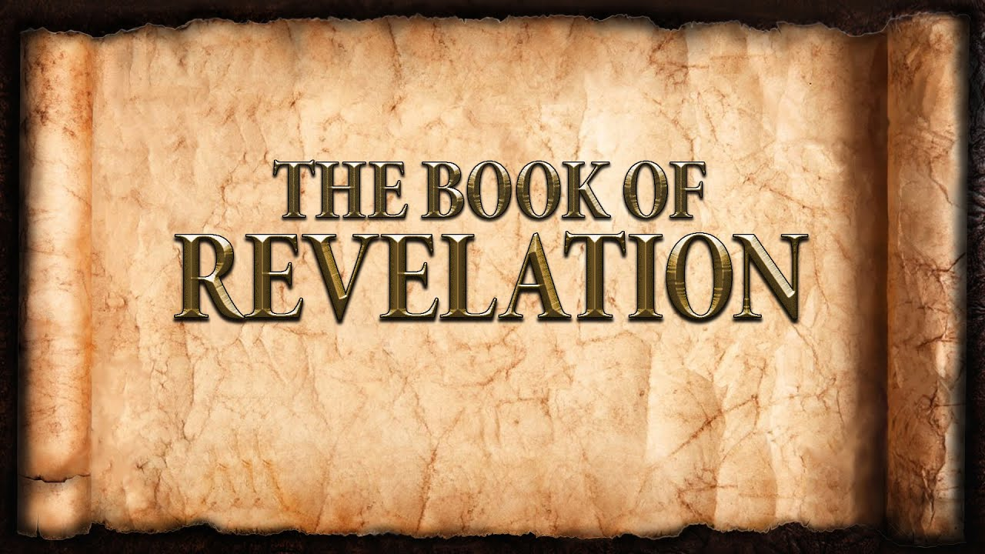
The revelation of Jesus Christ, which God gave him to show to his servants^{[a]} the things that must soon take place. [Revelation 1:1]
Week 11 March 19, 2023

Eschatology
- The divine conclusion and ultimate destiny of human souls.
- Old Testament believers awaited a future redeemer.
- Old Testament believers looked forward to the Kingdom of God.
- Old Testament believers anticipate a new covenant.
- Old Testament believers hoped for the outpouring of the Holy Spirit.
- Old Testament believers yearned for new heavens and the new earth
These hopes are fulfilled in Jesus Christ.
- Today, Christians live in the age of fulfillment and mission.
- Christians experience the tension of the “now” and the “not yet”
- Christians live now – between the two Advents of Christ.
- On the one hand, Christians receive the promised blessings through the Gospel and the Sacraments.
- On the other hand, Christians wait to enter the glories of heaven.
- Therefore, the life of a Christian is:
  - ______________________________________
  - ______________________________________
  - ______________________________________
  - ______________________________________

Signs of the End: Christ’s return
- First: __________________________________________________
- Second: _______________________________________________
- Third: _________________________________________________
- Fourth: ________________________________________________
- Fifth: __________________________________________________
  - The sign evidencing the grace of God.
  - The signs indicating the judgment by God.
    - ______________________________
    - ______________________________
    - ______________________________
    - ______________________________
  - The signs representing opposition to God.
    - ______________________________
    - ______________________________
    - ______________________________
The Seven Seals:
- The throne of God and the heavenly court.
- Do we really believe what we say we believe?
- “Around the throne was a rainbow.”
  - _________________________________________________
  - _________________________________________________
- 24 thrones with 24 elders.
  - Clothed in white.
  - Wearing crowns.
- 7 torches represent the Holy Spirit.
- 4 creatures represent all of creation.

