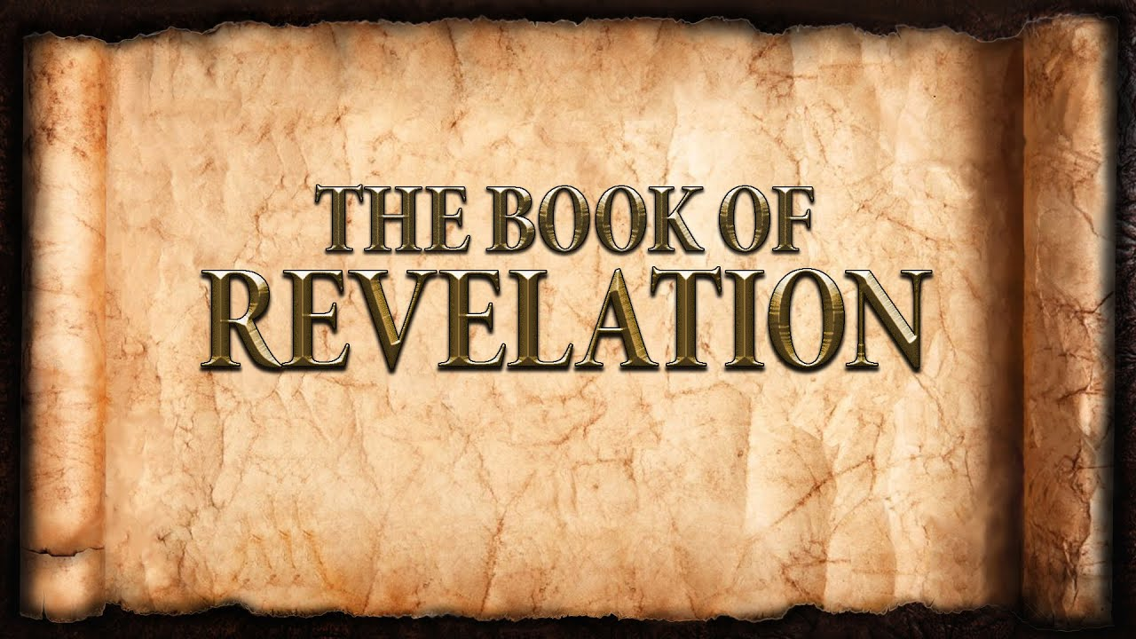
The revelation of Jesus Christ, which God gave him to show to his servants^{[a]} the things that must soon take place. [Revelation 1:1]
Week 12 March 26, 2023

Revelation 4 and 5
The Throne of God:
- The door was opened to the heavenly court.
- Do we really believe what we say we believe?
  - God Reigns.
  - God is Love.
  - God is Gracious.
  - Heaven is a wonderful place.
- “Around the throne was a rainbow.”
  - _________________________________________________
  - _________________________________________________
- 24 thrones with 24 elders.
  - Clothed in white.
  - Wearing crowns.
- 7 torches represent the Holy Spirit.
- 4 creatures represent all of creation in the service of God.
  - Authority of the lion.
  - Strength of the ox.
  - Intelligence of the man.
  - Endurance of the eagle.
- A reciprocal relationship.

The Scroll:
- Written “front and back”:
- Only One is worthy:
- The Lamb:
  - He was slain.
  - He is victorious.
  - 7 horns:
  - 7 eyes:
- A view of the God’s people from heaven:
  - Ransomed
  - Priests to our God
  - Rulers
  - Worshippers
  - Prayers
  - Myriads
- The message on the Scroll:

- Timeframe:

