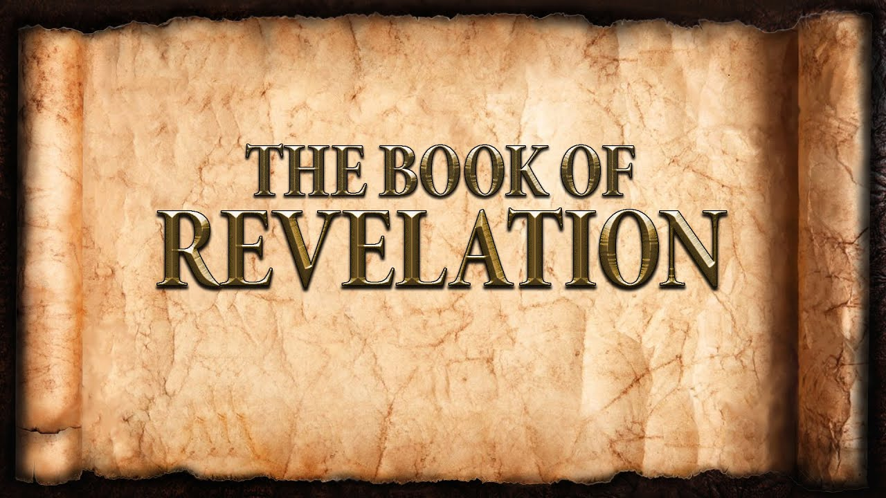
The revelation of Jesus Christ, which God gave him to show to his servants^{[a]} the things that must soon take place. [Revelation 1:1]
Week 13 April 2, 2023
Revelation 6
“The end result of the prophetic message, then, is not to give a predictable view of history, but rather to give a predictable view of the human condition in suffering and defeat because of human evil and rebellion against God, and a predictable knowledge of God’s terrible judgment. The purpose is to move all people to repentance and faith before the End, which in turn serves the ultimate purpose of displaying Christ’s majestic sovereignty for the salvation and hope of those who listen, repent, and believe.” (Revelation; Dr. Louis Brighton. p.151)

History Repeats:
- Three visions of seven scenes:
  - Too much:
  - Too much:
  - Three perspectives on the same events and God’s purpose.
  - Three: God’s [upper] story
  - Seven: God’s completed work (Genesis – Creation Account)
- Tribulation for the Church:
  - Erchomai (er’-Khom-ahee): to come
  - Blepo (blep’-o): to look at
  - Both verbs are: active and continuous.
  - Who says it? A living Creature
  - To whom is it said? The Apostle John
  - The tribulation will continue until Christ returns
The Seals:
- 1st Seal – The White Horse with Rider:
Now I watched when the Lamb opened one of the seven seals, and I heard one of the four living creatures say with a voice like thunder, “Come!” ² And I looked, and behold, a white horse! And its rider had a bow, and a crown was given to him, and he came out conquering, and to conquer.
  - An imposter.
  - Seeking to conquer the church.
- 2nd Seal – The Red Horse with Rider:
When he opened the second seal, I heard the second living creature say, “Come!” ⁴ And out came another horse, bright red. Its rider was permitted to take peace from the earth, so that people should slay one another, and he was given a great sword.
  - Spreading violence among people.
  - Hostility toward the people of God.
- 3rd Seal – The Black Horse with Rider:
When he opened the third seal, I heard the third living creature say, “Come!” And I looked, and behold, a black horse! And its rider had a pair of scales in his hand. ⁶ And I heard what seemed to be a voice in the midst of the four living creatures, saying, “A quart^{[a]} of wheat for a denarius,^{[b]} and three quarts of barley for a denarius, and do not harm the oil and wine!”
  - Scarcity and poverty.
  - Power and apathy.
- 4th Seal – The Pale (Gray) Horse with Rider:
When he opened the fourth seal, I heard the voice of the fourth living creature say, “Come!” ⁸ And I looked, and behold, a pale horse! And its rider's name was Death, and Hades followed him. And they were given authority over a fourth of the earth, to kill with sword and with famine and with pestilence and by wild beasts of the earth.
  - Constant calamities on the earth.
  - Extensive but not the end.
- 5th Seal – The Martyrs:
When he opened the fifth seal, I saw under the altar the souls of those who had been slain for the word of God and for the witness they had borne. ¹⁰ They cried out with a loud voice, “O Sovereign Lord, holy and true, how long before you will judge and avenge our blood on those who dwell on the earth?” ¹¹ Then they were each given a white robe and told to rest a little longer, until the number of their fellow servants and their brothers^{[c]} should be complete, who were to be killed as they themselves had been.
  - Given white robes.
  - Suffering for the sake of the Gospel.
- 6th Seal – The Wrath of the Lamb: (an oxymoron)
When he opened the sixth seal, I looked, and behold, there was a great earthquake, and the sun became black as sackcloth, the full moon became like blood, ¹³ and the stars of the sky fell to the earth as the fig tree sheds its winter fruit when shaken by a gale. ¹⁴ The sky vanished like a scroll that is being rolled up, and every mountain and island was removed from its place. ¹⁵ Then the kings of the earth and the great ones and the generals and the rich and the powerful, and everyone, slave^{[d]} and free, hid themselves in the caves and among the rocks of the mountains, ¹⁶ calling to the mountains and rocks, “Fall on us and hide us from the face of him who is seated on the throne, and from the wrath of the Lamb, ¹⁷ for the great day of their wrath has come, and who can stand?”
  - In His great love He ransomed all mankind.
  - In His great wrath He will judge all who reject His love.
- 7th Seal – Wait for it…….

