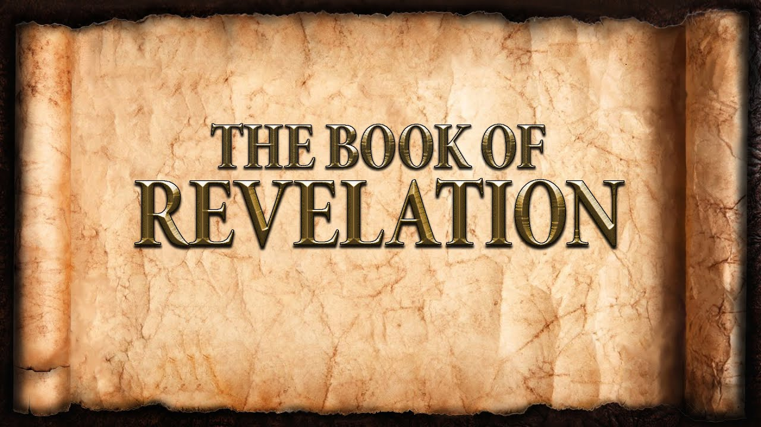
The revelation of Jesus Christ, which God gave him to show to his servants^{[a]} the things that must soon take place. [Revelation 1:1]
Week 14 April 16, 2023

Revelation 7
Of Utmost Importance:
And after [meta = in the midst of] this I saw four angels standing at the four corners of the earth, holding back the four winds of the earth, that no wind might blow on earth or sea or against any tree. [7:1]
- Four angels, four corners, four winds:
  - The whole earth destroyed – God’s judgment.
  - Everything, even to the last tree – the flood.
  - But not until God’s people are safe.
  - Simultaneous and throughout the previous 6 seals.
  - And then the end.
- Seal of the Living God
  - The Gospel
  - Baptism
    - “Receive the sign”
    - The Holy Spirit. [Ephesians 1:13-14]
- The Church Militant
  - The end of the world is postponed. [1st Peter 3:15]
  - Sent and Going. [Romans 10:14-17]
  - God is central. [Numbers 2]
- The Church Triumphant
  - Who are they? From where did they come?
  - Home and resting.
  - Suffering results in salvation.
The 7th Seal: The End!
When the Lamb opened the seventh seal, there was silence in heaven for about half an hour. [8:1]

The 7 Trumpets: Warning!
- Purpose: The judgments of God.
- Purpose: The steadfastness of the Church.
- Purpose: The repentance of sinners.
- Purpose: The reconciliation of God and mankind (3 + 4 = 7)
- Introduction to the trumpets:
  - Trumpets were a means of signaling.
  - Prayers of the saints:
    - The angel was given much incense.
    - Saints pray, “Thy Kingdom Come.”
    - Saints pray, “For thine is the kingdom and the power and the glory forever and ever.
  - The Seals revisited:

  - To whom are the Trumpets directed?

- Trumpets 1 - 4 [8:6-12]
  - 1st Trumpet
    - Hail, fire, and blood thrown upon the earth.
    - 1/3 of the earth, 1/3 of the trees, all the grass
  - 2nd Trumpet
    - Something like a mountain thrown into the sea.
    - 1/3 of sea, 1/3 of sea creatures, 1/3 of the ships
  - 3rd Trumpet
    - A great star named Wormwood fell on the earth
    - 1/3 of the rivers and 1/3 of the waters
  - 4th Trumpet
    - 1/3 of the sun, 1/3 of the moon, and 1/3 of the stars are darkened.
    - 1/3 of the day and 1/3 of the night
- The Seven Woes [Matthew 23]

- The greatest judgment…

