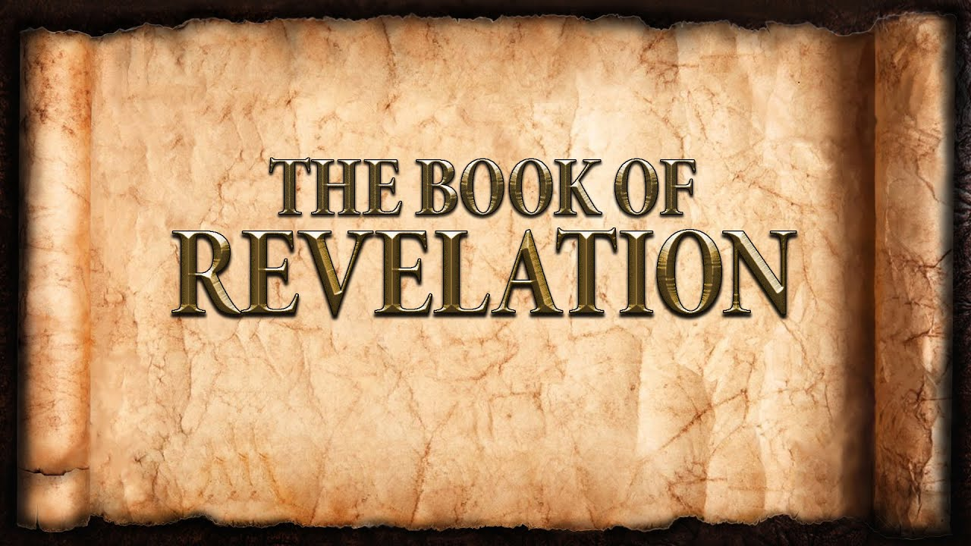
The revelation of Jesus Christ, which God gave him to show to his servants^{[a]} the things that must soon take place. [Revelation 1:1]
Week 15 April 23, 2023

Revelation 8
The 7th Seal: The End!
When the Lamb opened the seventh seal, there was silence in heaven for about half an hour. [8:1]

The 7 Trumpets: Warning!
- Purpose: The judgments of God.
- Purpose: The steadfastness of the Church.
- Purpose: The repentance of sinners.
- Purpose: The reconciliation of God and mankind (3 + 4 = 7)
- Introduction to the trumpets:
  - Trumpets were a means of signaling.
  - Prayers of the saints:
    - The angel was given much incense.
    - Saints pray, “Thy Kingdom Come.”
    - Saints pray, “For thine is the kingdom and the power and the glory forever and ever.
  - The Seals revisited:

  - To whom are the Trumpets directed?

- Trumpets 1 - 4 [8:6-12]
  - 1st Trumpet
    - Hail, fire, and blood thrown upon the earth.
    - 1/3 of the earth, 1/3 of the trees, all the grass
  - 2nd Trumpet
    - Something like a mountain thrown into the sea.
    - 1/3 of sea, 1/3 of sea creatures, 1/3 of the ships
  - 3rd Trumpet
    - A great star named Wormwood descends to the earth
    - 1/3 of the rivers and 1/3 of the waters
  - 4th Trumpet
    - 1/3 of the sun, 1/3 of the moon, and 1/3 of the stars are darkened.
    - 1/3 of the day and 1/3 of the night

Then I looked, and I heard an eagle crying with a loud voice as it flew directly overhead, “Woe, woe, woe to those who dwell on the earth, at the blasts of the other trumpets that the three angels are about to blow!” [8:13]

- The Seven Woes [Matthew 23]

  - 5th Trumpet: The first woe!
    - Bottomless Pit:
      - Smoke
      - Locusts
      - Torment - not death
        - Who?
        - How Long?
      - Under the authority of the destroyer.
- The greatest sin: ________________
- The greatest judgment: _______________________

