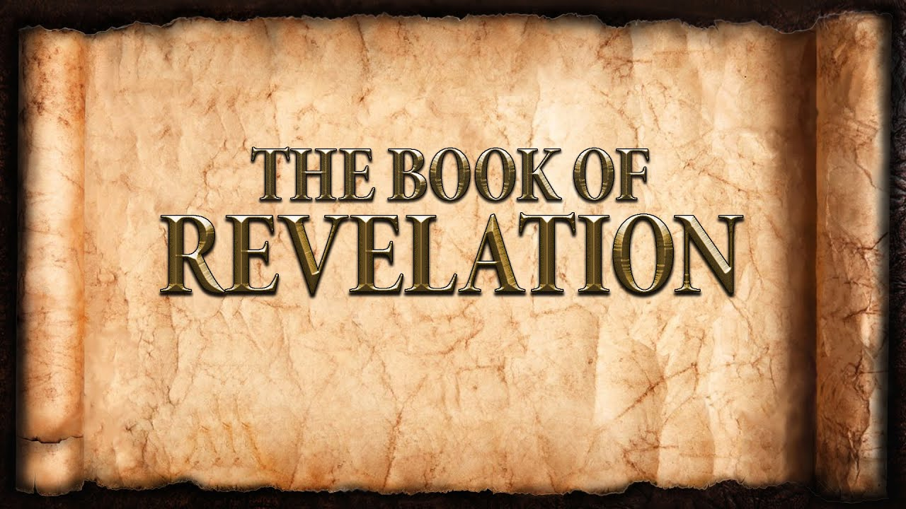
The revelation of Jesus Christ, which God gave him to show to his servants^{[a]} the things that must soon take place. [Revelation 1:1]
Week 16 April 30, 2023

How far will God go to bring people to repentance?

Remember:
- The Book of Revelation is written to: The Church
  - Specifically: seven churches.
  - Universally: the whole church.
- The Book of Revelation has a two-fold purpose:
  - First purpose: The exalted reign of Christ.
  - Second purpose; The Church and her mission.
- The Book of Revelation has a unique perspective:
  - Might be the most evangelistic book of the Bible.
  - Salvation history from the perspective of heaven.
  - It includes the: past, present, and future.
  - It describes judgment and salvation with stark contrast.
  - It utilizes imagery and figurative language.

Numbers:
- 42 months
- 1260 days
- 3.5 years
- 3.5 days
- Time, Times, and half a Time

The 5th Trumpet: The First Woe
- Smoke and Locust-Scorpions: Torment
- Divine Judgment: Repentance
The 6th Trumpet: The Second Woe

- Four Angels: The entire cavalry. [9:13-19]
  - Released:
  - Breastplates:
  - Horses:
  - Mission:

- Mankind: the unredeemed. [9:20-21]
  - Refused to repent.
  - Remained true to their idols.
    - False Religions
    - Intellect
    - Modern culture
    - Civilized people

The Angel and a Little Scroll

- A message for the entire world. [10:1-7]
  - He stands and hollers.
  - He swears an oath.
  - Some things are kept hidden.
- The message: [10:8-11]
  - Take it in.
  - It is bitter and sweet.
  - Speak it to everyone.

The Two Witnesses [11:1-14]

- But first: a measurement
- Legal Testimony
- Not who – but what
- The Word of the LORD

