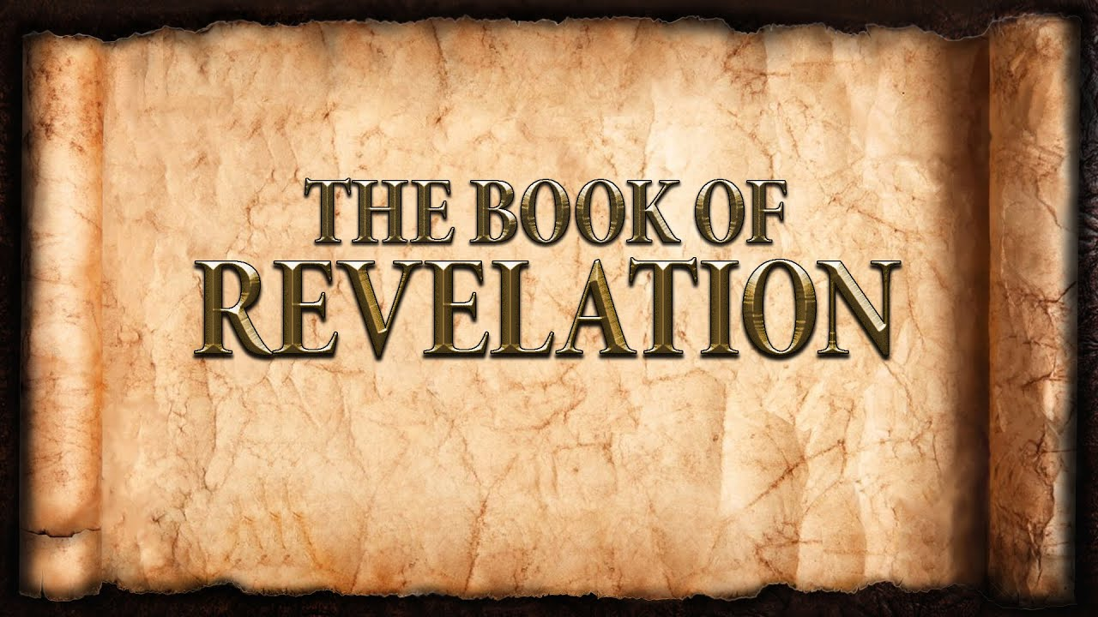
The revelation of Jesus Christ, which God gave him to show to his servants^{[a]} the things that must soon take place. [Revelation 1:1]
Week 17 May 7, 2023

The Two Witnesses [11:1-14]

- But first: a measurement
- Legal Testimony
- Not who – but what
- The Message
  - The Word of the LORD
  - Repentance
- Two Olive Trees/Two Lampstands
- The Witnesses will complete their Testimony
- Spiritual Forces of Evil appear to win
  - Silenced their testimony
  - Rejoiced over their silence
  - Celebrated their rebellion
  - Short-lived and predetermined
- The Word of God is removed forever.

The Angel, A Little Scroll, & Two Witnesses
- The full gospel is proclaimed: Law & Gospel
- To people from all the earth
- Through all generations.

The 7th Trumpet: The Third Woe. The end!
- Judgment Day is over.
- Evil and rebellion have been eradicated.
- The LORD Jesus Christ reigns!
The Woman, the Dragon & two Beasts
- The woman is symbolic of the Church.
  - Given heavenly beauty.
  - Must live in the wilderness to complete her mission.
  - Will be cared for by God.
- The child is symbolic of the Jesus Christ and His Incarnation.
- The red dragon is Satan
  - He seeks to destroy the savior
  - He is thrown down.
- The first beast: servant of the dragon
  - Makes war against the church with ferocious power
  - Seven heads:
  - Ten horns:
  - Seven “crowns”:
  - Mortally wounded but alive.
- The second beast: servant of the first beast
  - Makes war against the church with deceptive messages
  - It has a number: ______________

