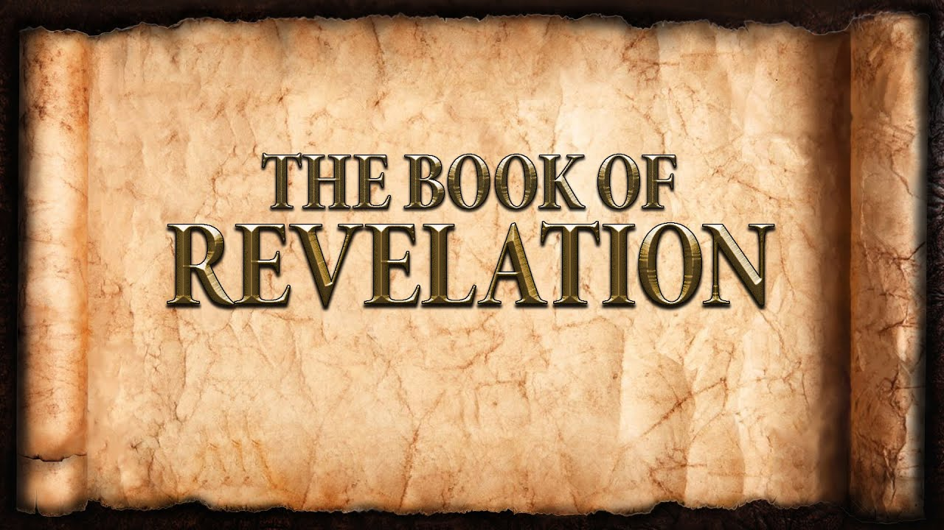
The revelation of Jesus Christ, which God gave him to show to his servants^{[a]} the things that must soon take place. [Revelation 1:1]
Week 18 May 14, 2023

The Red Dragon & Two Beasts [13:5-8, 11 & 12, 11:9 & 10]

- Anti-Christian power.
- Anti-Christian propaganda.
- People fear, love, and trust the beasts.
- People adore and give allegiance to the beast.
The Lamb and His 144,000 [14:1-5]

- The Lamb is Christ.
- The 144,000 are all who fear, love, and trust God.
  - They were purchased
  - They follow the Lamb.
  - They are righteous.
- Mount Zion = heaven.
- The actual number is growing until the last one.

The Virgins

- The Bride of Christ.
  - Without spot or blemish.
  - Complete devotion.
- Israel as adulterous.
  - They chase after false gods.
  - They exchange truth for a lie.

Babylon the Great [14:6-13]

- The people of the anti-Christian city.
- A resident of one of the other.
- As great as heaven is, hell is equally opposite.
  - Awful.
  - Eternal.
- Fallen! Fallen! = utterly destroyed.

The Endurance of the Saints [13:10 & 14:12]

- Endurance during personal suffering
- Endurance for the purpose of proclamation
- The eternal Gospel.
  - One Gospel [Acts 4:8-12]
  - One Gospel for all people, all, places, and all times.
- Those who die in the LORD are blessed.

Sickles are for Harvesting

- The first sickle is in the hands of Christ. [14:14-16]
- The believers are harvested first and brought in.
- The second sickle in the hands of an angel. [14:17-20]
- The unbelievers are harvested and crushed.

The 7 Bowls of God’s Wrath [16:1-21]

- They refused to repent.
- It is finished.

