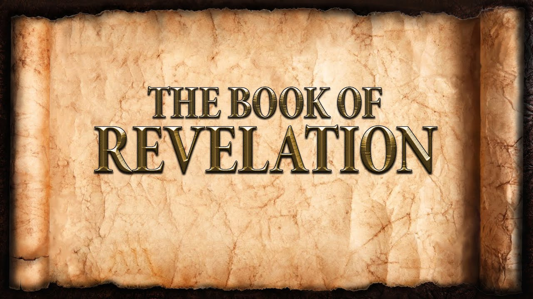
The revelation of Jesus Christ, which God gave him to show to his servants^{[a]} the things that must soon take place. [Revelation 1:1]

Exodus 3:14 “I AM” = Yahweh
Gospel of John |  | Apocalypse of John
“I Am” Statements | Sign Miracles | “I Am” Statements
6:35, 41, 48-51  Bread of Life | 6:1-15  Feeding the Multitude | 1:8  Alpha & Omega
8:12 - 9:5  Light of the World | 9:1-41  Sight for the blind man | 1:17  The First & The Last
10:7-9  The Door | 5:1-15  The Healing of the invalid | 1:18  He that lives
10:11-14  The Good Shepherd | 6:16-21  Walks on Water | 21:6  Alpha & Omega
11:25  The Resurrection | 11:1-44  Raises Lazarus from the dead | 22:13  Alpha & Omega
14:6  The Way, Truth & Life | 4:46-54  Healing of the Official’s Son | 22:16  Root & Offspring
15:1-5  The True Vine | John 2:1-12  Change Water into Wine | 22:16  Bright Morning Star
John 18:5-6 “I AM” _____________ _____________
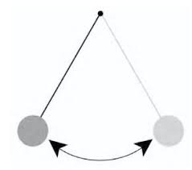
Keys to Understanding:
- Is The Book of Revelation:
  - Historical?
Now Only
1st Corinth. 15
Eternity Only
2nd Thess. 3

  - Futuristic?
  - Present?
- The Book of Revelation gives us a perspective:
  - Heaven and Earth
  - The Second Advent of Christ
  - Jesus Christ
  - Suffering: Matthew 5:11-12 & Revelation 6:9-11
  - The Church

- Numbers
  - “3” = ________________________________________________________
  - “4” = ________________________________________________________
  - “7” = __________________________ & ____________________________
  - “3.5” = _______________________________________________________
  - “6” = ________________________________________________________
  - “10” = _______________________________________________________
  - “12” = _______________________________________________________

- Authorship
  - The Apostle John
    - An eyewitness of Christ’s earthly ministry
    - John is suffering because of abiding in Christ
    - According to tradition, John is the last living Apostle
    - Why? _____________________________________

- Names and Titles of Jesus

