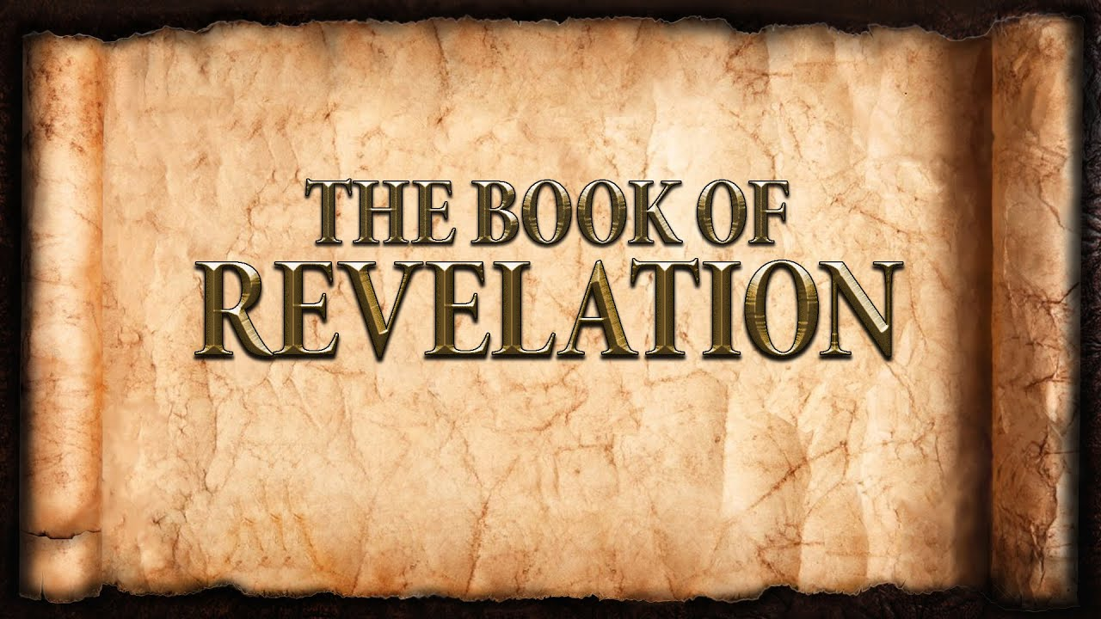
The revelation of Jesus Christ, which God gave him to show to his servants^{[a]} the things that must soon take place. [Revelation 1:1]
Week 3 January 22, 2023

- Authorship
  - The Apostle John
    - An eyewitness of Christ’s earthly ministry
    - John is suffering because of abiding in Christ
    - According to tradition, John is the last living Apostle
    - Why? _____________________________________

- Names and Titles of Jesus
  - ________________________________________________
  - ________________________________________________
  - ________________________________________________
  - ________________________________________________
  - ________________________________________________
  - ________________________________________________

The Seven Churches
I was in the Spirit on the Lord's day, and I heard behind me a loud voice like a trumpet ¹¹ saying, “Write what you see in a book and send it to the seven churches, to Ephesus and to Smyrna and to Pergamum and to Thyatira and to Sardis and to Philadelphia and to Laodicea.” [Revelation 1:10-11]
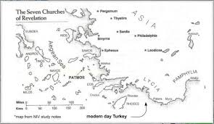

Ephesus:

Smyrna:

Pergamum:

Thyatira:

Sardis:

Philadelphia:

Laodicea:

Stars…..Lampstands…..Angels…..Churches
- Stars:
- Angles:
- Lampstands:

Take Away Messages:
- Christ is actively involved.
- The Church of Christ is to be actively involved.
- The “7 Churches” are representative of the whole Church.
  - All places.
  - All people.
  - All times.

