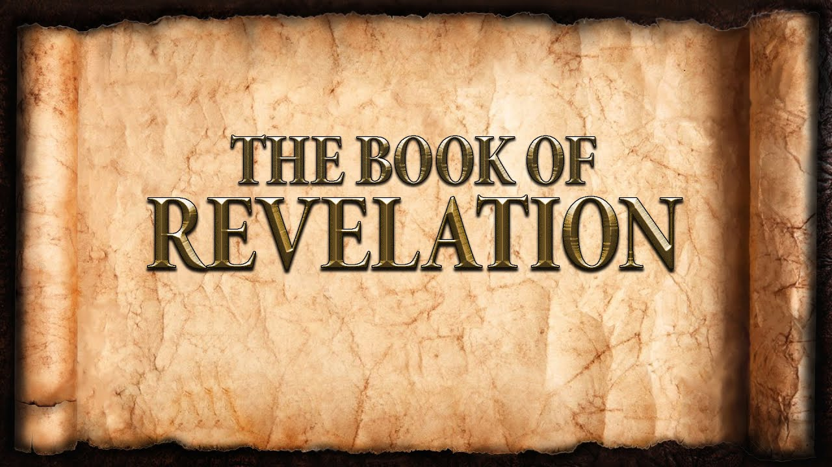
The revelation of Jesus Christ, which God gave him to show to his servants^{[a]} the things that must soon take place. [Revelation 1:1]
Week 5 February 5, 2023

7 Letters – 7 Greetings
Names & Titles of Christ:
- _________________________
- _________________________
- _________________________
- _________________________
- _________________________
- _________________________
- _________________________
“To the angel of the church in Ephesus write: ‘The words of him who holds the seven stars in his right hand, who walks among the seven golden lampstands.

“And to the angel of the church in Smyrna write: ‘The words of the first and the last, who died and came to life.

“And to the angel of the church in Pergamum write: ‘The words of him who has the sharp two-edged sword.

“And to the angel of the church in Thyatira write: ‘The words of the Son of God, who has eyes like a flame of fire, and whose feet are like burnished bronze.

“And to the angel of the church in Sardis write: ‘The words of him who has the seven spirits of God and the seven stars.

“And to the angel of the church in Philadelphia write: ‘The words of the holy one, the true one, who has the key of David, who opens and no one will shut, who shuts and no one opens.

“And to the angel of the church in Laodicea write: ‘The words of the Amen, the faithful and true witness, the beginning of God's creation.

7 Churches
Ephesus
- Paul spent 3 years in Ephesus (Acts 19)
- Paul charged the elders of the Church in Ephesus with responsibility (Acts 20)
- The church members are praised by Christ:
  - Toil for the kingdom.
  - Endurance in the race
  - Stand firm for the truth.
  - Hate the works of the Nicolaitans.
- The church members are rebuked by Christ:
  - Abandoned love.
- The church members are corrected by Christ:
  - Remember!
  - Repent!
- The church members are given a promise from Christ:
  - Removal of lampstand.
  - Eternal life with God.

Smyrna
- The church members are suffering:
  - Pressure.
  - Persecution.
- The church members are praised by Christ:
  - Endurance.
  - Rich.
- The church members are encouraged by Christ:
  - Do not fear.
  - Remain faithful through faith.
- The church members are given a promise from Christ:
  - Victory!
  - Eternal life!

