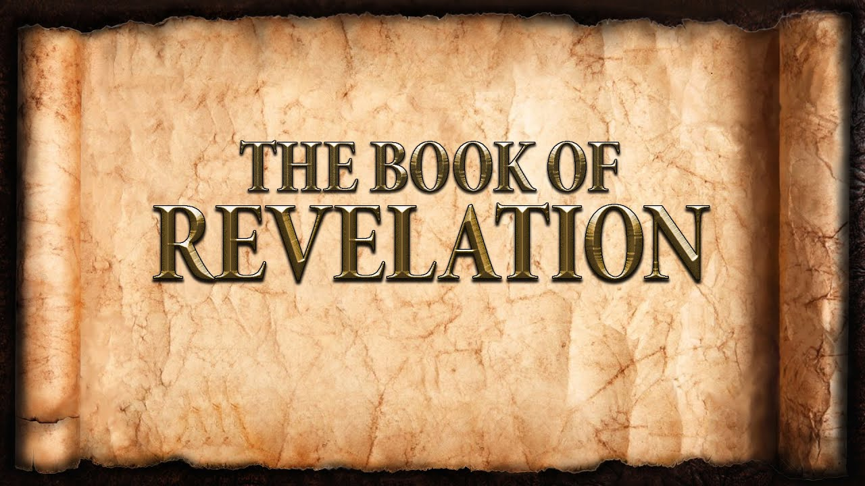
The revelation of Jesus Christ, which God gave him to show to his servants^{[a]} the things that must soon take place. [Revelation 1:1]
Week 6 February 12, 2023

7 Churches
Names & Titles of Christ:
- _________________________
- _________________________
- _________________________
- _________________________
- _________________________
- _________________________
- _________________________

Smyrna
- The church members are suffering:
  - Pressure.
  - Persecution.
- The church members are praised by Christ:
  - Endurance.
  - Rich.
- The church members are encouraged by Christ:
  - Do not fear.
  - Remain faithful through faith.
- The church members are given a promise from Christ:
  - Victory!
  - Eternal life!

Pergamum
- The church members are commended by Christ:
  - Have not given up in the face of opposition.
  - Continue to claim the name of Christ.
- The church members are compromising:
  - Balaam’s Treachery – Satan’s throne (Numbers 22-24)
    - He acknowledged the Lord with his mouth.
    - He persisted in godless practices.
    - He practiced hypocrisy.
  - Balaam’s Deception (Numbers 25 & 31:16)
    - He devised a plan.
    - The people went for it.
  - Nicolaitans Influence
    - Compromise for the sake of “peace”.
    - Moderate convictions for the approval of men.
- The church members are warned by Christ:
  - Jesus does not tolerate compromise.
  - Jesus will war against the unrepentant.
  - Jesus speaks, we must listen.
- The church members are given promises from Christ:
  - Grace that is all-sufficient.
  - Approval based on the righteousness of Christ.
  - Identity based on the will of God.
- The church members are called to repentance.
  - Fear, love & trust God alone.
  - We cannot have divided loyalties.
  - There is nothing that cannot be forgiven.
  - God’s love is known by those who receive.

