The revelation of Jesus Christ, which God gave him to show to his servants[[a](https://www.biblegateway.com/passage/?search=revelation+1&version=ESV#fen-ESV-30683a)] the things that must soon take place.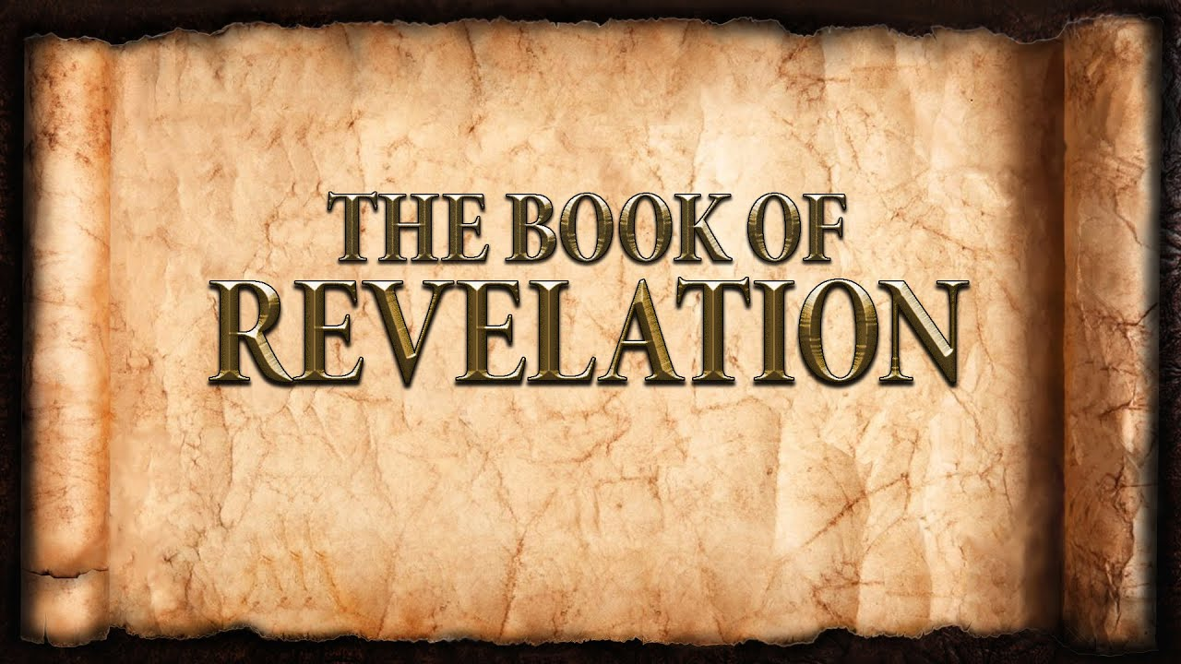 [Revelation 1:1]

**Week 9**  March 5, 2023

Names & Titles of Christ:

1. _________________________
2. _________________________
3. _________________________
4. _________________________
5. _________________________
6. _________________________
7. _________________________

7 Churches

**Laodicea**

* The church members deceived themselves:
  + They were the source of all they **needed**.
  + They acted like the church belonged to **them**.
  + They thought they were the **elite**.
* Jesus reveals His pre-eminence to the church:
  + The Amen
  + The Faithful and True Witness
  + The Ruler of God’s Creation
* The church members are rebuked:
  + They had become **apathetic** about faith.
  + They were **devoted** to their personal interests.
* The church members receive:
  + A Quit Claim Deed
  + **Discipline**.
  + A call to **repentance** with **zeal**.

Summary

* The Church **belongs** to Jesus.
* Jesus is **intimately** involved in His Church.
* These letters are written to **His Church**.
* The **right** response is **Mary’s** response.
* Consider and **celebrate** that your name is written in the Book of Life.
* The Church is the **hope** of the nations.

Does Jesus use Incentives?

|  |  |
| --- | --- |
| **Agreement** | Access to the Tree of Life |
| **Faithful** | Protection from eternal death |
| **Single – mindedness** | Complete Approval |
| **Purity** | Ultimate significance |
| **Steadfast** | Extreme honor |
| **Faith** | Courage and hope |
| **All in** | Shared authority and responsibility |

Millennial Views