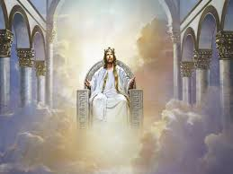
PHILIPPIANS
The Exaltation of Christ
⁹ Therefore God has highly exalted him and bestowed on him the name that is above every name, ¹⁰ so that at the name of Jesus every knee should bow, in heaven and on earth and under the earth, ¹¹ and every tongue confess that Jesus Christ is Lord, to the glory of God the Father. [Philippians 2:10-11]
- The Context:
  - Christ _________________ himself.
  - Christ was _____________________ by God [Θεὸς].
  - Lesson to be learned: _______________________________________[Prov. 27:2]
  - Therefore = _____________________________________.
    - Men at work: ___________________________________. {Acts 2:22-23]
    - Jesus at work: ___________________________________. [John 19:30, Matthew 27:50 & Mark 15:37]
    - God at work: ___________________________________. [Acts 2:24]
- The stages of Christ’s Exaltation
  - The descent into hell: [1st Peter 3:18-20]
  - The resurrection: [Eph. 1:20, Rom. 6:4] & [John 2:18-21]
  - The forty days between Resurrection and Ascension: [Acts 1:3]
  - The Ascension: [Acts 1:9-11]
  - Seated at the right hand of God: [Eph. 1:20-23]
  - The Second Advent: [Acts 1:9-11, John 5:28-29, Matt. 25:31]
- A little more on attitude
  - Do all for the ___________________ of God. [1st Corinthians 10:31]
  - No room for _____________________.
  - Our salvation is primarily for the __________________________.
  - Have the same attitude as Christ: ____________________. [1st Peter 5:6]

