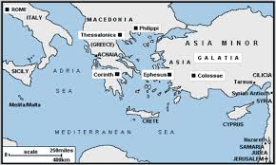
PHILIPPIANS
Introduction &
Background
- Geography
  - The land was fertile
  - A Gate City
  - Gold mines
- History
  - Beginnings date back to 4th century BCE
  - Philip II took over in 356 BCE
  - Came under Roman rule in 168 BCE
  - The battle of Philippi in 42 BCE
  - Apostle Paul, Silas and Timothy arrive in 49 CE
- Political
  - The Battle of Philippi
    - Mark Antony and Octavian
    - Brutus and Cassius
  - The Roman Empire over the Roman Republic
  - Roman colony
    - Veteran retirement village
    - Military outpost
    - Special benefits as a colony
      - Self-government
      - Freedom from paying taxes
      - Same rights as those who live in Italy
- Religious
  - Syncretistic practices
    - Emperor worship
    - Egyptian gods: Isis & Serapis
    - Small Jewish population
  - No Christians
- Themes
  - Christians first, Romans second
  - Joy
  - Christ’s deity
  - Fellowship

