PHILIPPIANS
How did we get here?
- Council at Jerusalem
  - Conflict follows Paul
    - Acts 13:44-45=
    - Acts 13:50=
    - Acts 14:19=
    - Acts 15:1-2=
  - Unless you obey the custom, you cannot be saved.
  - Judgment rendered by James and the Council
  - Immediate significance
- The Distinctions
  - There is no distinction between “us and them”
  - There is a distinction between the Law and the Gospel
  - Some went unauthorized and some were sent
- The dynamic duo
  - Paul and Barnabas
    - “Set apart for the work”
    - Travel companions
    - Ministry companions
  - The Reunion Tour
  - Complement or Compete
- Kingdom Expansion
  - 2 new teams
    - Barnabas and Mark
    - Paul and Silas (and Timothy)
    - The circumcision of Timothy
  - The message: …through the grace of our Lord Jesus Christ that we are saved
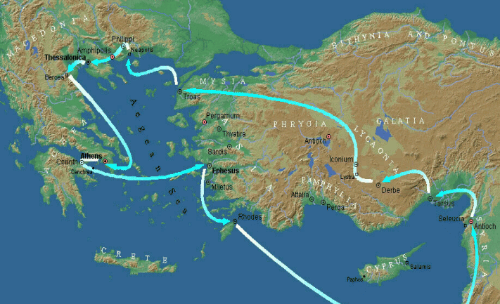
  - The Man of Macedonia

