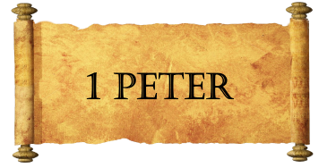
Week Two
Key Themes:
- God’s grace and forgiveness:

- The most dangerous threat against Christianity:

- Selective amnesia:

- Encouragement to faithfulness:

- “The Already and the Not Yet”:

Background:
- When did Peter write this letter?
- Who did Peter write it to?
- Why did Peter write it?
Peter, an apostle of Jesus Christ,
To those who are elect exiles of the Dispersion in Pontus, Galatia, Cappadocia, Asia, and Bithynia, ² according to the foreknowledge of God the Father, in the sanctification of the Spirit, for obedience to Jesus Christ and for sprinkling with his blood:
May grace and peace be multiplied to you.

God has a ______________:
Holy Spirit is at _____________:
Jesus has a ________________:
We are _________________:
Be __________________!

