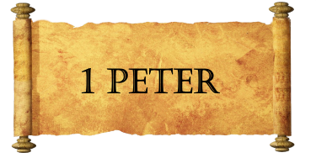
Week Three
Always Remember:
- Your salvation is all _______________________.
  - His _________________.
  - His _________________.
    - ___________________
    - ___________________
    - ___________________
  - His ________________.
- Your blessing is ________________________
- Your opportunity is to bless fellow pilgrims with _________________ and ___________.
- Your invited to:
  - _________________________________________________.
  - _________________________________________________.
  - _________________________________________________.
God Gives Guarantees:
- Guarantees shape our _______________________.
  - An inheritance that is ____________________________.
  - An inheritance that is ____________________________.
  - An inheritance that is ____________________________.
- The location of your inheritance:
  - ______________________.
  - ______________________.
  - Matthew 6:19-21
Live _________________! No matter what.
- Believers are very ____________________.
  - This life is _____________________.
  - Faith in Christ is the most _____________________.
    - The faith you _____________ is _________________.
    - Like gold, your ____________ and __________ becomes more malleable.
    - It is through faith that you receive the ______________ of your _______.
- You have not _______________ God, and yet you _______________ Him.
- The Holy Spirit:
  - __________________ your spiritual ears.
  - __________________ your hard heart.
  - __________________ your faith to Christ.

