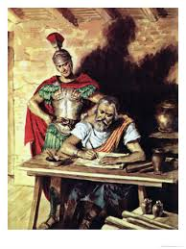
PHILIPPIANS
Joy - Stealers

- Paul encountered joy stealers
  - Acts 28:16 & 30-31
  - Acts 28:17-20
  - Acts 28:23-24
- Jesus encountered joy stealers
  - Isaiah 53
  - Philippians 2
- You have encountered joy stealers
  - _______________________________
  - _______________________________
  - _______________________________
  - _______________________________
- Word study
  - Joy
    - Nehemiah 8:10
    - John 15:11
  - Mind
    - Romans 12:2
    - Philippians 2:5
- Is Paul the expert on joy?

