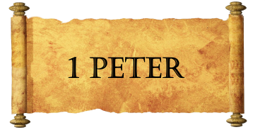
Week Four
Let’s Review:
- Peter clarifies who we are:
- Peter clarifies how we became who we are:
- Peter teaches about how God’s people live.
FREEDOM!
- Freedom from _______________________________.
- Freedom to truly live during our ___________________________.
- Freedom to _________________________.
Not by Osmosis
- It will get ________________ before it gets __________________.
- It will be _________________ and ___________________ challenging.
- It will require: ______________, ______________, and _______________.
- It is an imitation of __________________.
- It is from the __________________.
A Very Special Relationship
- ____________________ by The Holy One
- ____________________ by The Righteous Father
- ____________________ to be Children of Obedience
Let’s Talk Motivation
- Prior ________________
- Sacrificial ________________
- Healthy ____________________
- Proactive ________________

