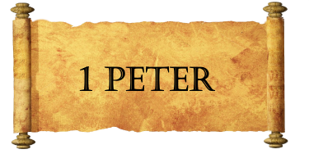
Week Six
American Values:

Kingdom Values:

Kingdom People:

How Shall We Live:

What Do We Hold in Tension:

