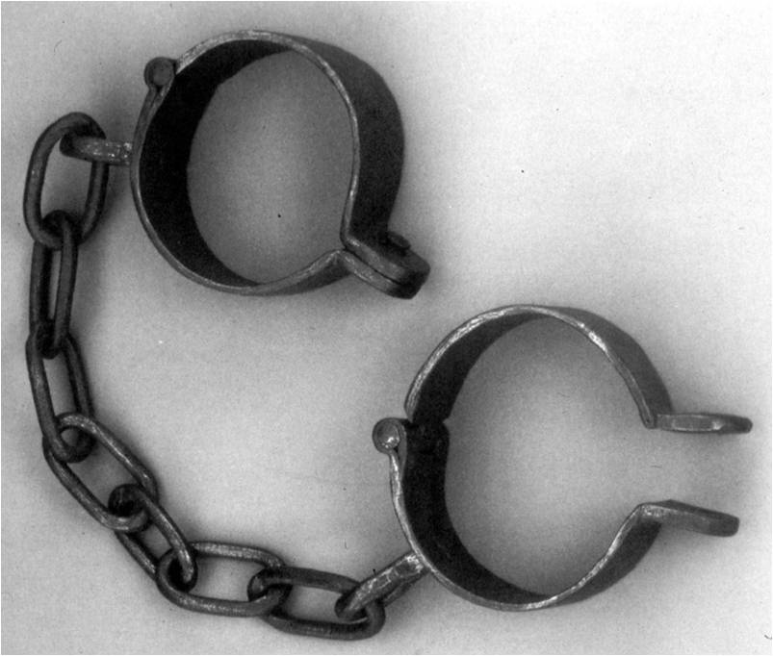
PHILIPPIANS
The Gospel Unleashed

Paul’s Chains Advance the Gospel
¹² Now I want you to know, brothers and sisters,^{[b]} that what has happened to me has actually served to advance the gospel. ¹³ As a result, it has become clear throughout the whole palace guard^{[c]} and to everyone else that I am in chains for Christ. ¹⁴ And because of my chains, most of the brothers and sisters have become confident in the Lord and dare all the more to proclaim the gospel without fear. ¹⁵ It is true that some preach Christ out of envy and rivalry, but others out of goodwill. ¹⁶ The latter do so out of love, knowing that I am put here for the defense of the gospel. ¹⁷ The former preach Christ out of selfish ambition, not sincerely, supposing that they can stir up trouble for me while I am in chains. ¹⁸ But what does it matter? The important thing is that in every way, whether from false motives or true, Christ is preached. And because of this I rejoice. [Philippians 1:12-18]
- Keys to the Text:
  - Things that happened to Paul
  - Advance/Furtherance: _____________________________________
  - Supply: __________________________________________________
  - Progress: ________________________________________________
  - Proclaim (Speak/Say): _______________________________________
  - Preach: ___________________________________________________
- “I want you to know…”
  - ______________________ have advanced the ________________.
  - His chains have _________________ the Gospel, not ______________ it.
  - PERSPECTIVE CHECK: What has happened to you that advanced the Gospel?
  - How do chains give confidence and dispel fear?
- Motivations for Preaching the Gospel
  - “envy and rivalry”: _____________________________________________
  - “goodwill”: ___________________________________________________
  - PERSPECTIVE CHECK: What is the most important thing?
  - Why exactly did Paul rejoice?
- Single mindedness
  - “It makes no difference what happens to ______________, just as long as Christ is __________________ and the Gospel is _________________________________.”
  - Paul did not find joy in ______________________. He found joy in ___________________ _____________ to ____________________!
  - The secret is this: ____________________________________________________________.

