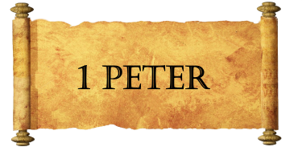
Week Seven
“No People”:
And I will have mercy on No Mercy, and I will say to Not My People,^{[i]} ‘You are my people’; and he shall say, ‘You are my God.’” [Hosea 2:23]
Once you were not a people, but now you are God's people; once you had not received mercy, but now you have received mercy. [1st Peter 2:10]
- A very special _______________.
- A very special ______________________.
- A great sense of _________________ and ________________.
- A great reason for ___________________________________________.
Obstacles:
List some obstacles that prevent us from ______________________:

List some obstacles that receiving mercy ______________________:

Honorable Conduct:
- _____________________ to one – _________________ to another.
- Treat everyone with _______________ – silence _______________.
- _________________ for everyone – ______________ God.
- Work with ______________ – suffer with ________________.

